1. 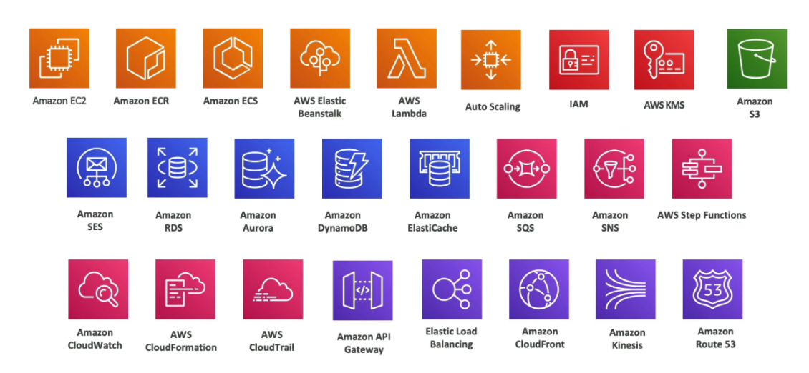**What we will learn in this course**
2. **AWS Cloud Overview**

**AWS Cloud History**

**AWS Cloud Use cases**

**AWS Global Infrastructure**

AWS Global Infrastructure is the backbone of AWS services, designed for scalability, security, and fault tolerance. It consists of Regions, Availability Zones, Data Centers, and Edge Locations to ensure low latency, high availability, and compliance with local regulations.

AWS Region

An AWS Region is a geographic location with multiple isolated Availability Zones, providing independence and compliance with local laws. For example, **us-east-1 (North Virginia)** serves North America, while **ap-south-1 (Mumbai)** caters to South Asia. Regions allow users to deploy applications close to their customers for reduced latency.

AWS Availability Zones (AZs)

AZs are isolated clusters of data centers within a Region, connected by low-latency networks. Each AZ is physically separated to mitigate risks like power outages. For instance, the **us-east-1 Region** has six AZs (e.g., us-east-1a, us-east-1b), enabling applications to remain highly available during failures.

AWS Data Centers

AWS Data Centers are secure, state-of-the-art facilities housing the hardware for AWS services. They ensure redundancy through power backups and cooling systems, supporting infrastructure like EC2 and S3. Multiple data centers within AZs enhance reliability and allow seamless scaling.

AWS Edge Locations/Points Of Presence (Pops)

Edge Locations, also known as Points of Presence, are globally distributed sites that cache content via services like CloudFront, ensuring low latency for users. For example, streaming a video from **CloudFront's Edge Location in Kathmandu** provides faster delivery to nearby users compared to accessing the data directly from an AWS Region.

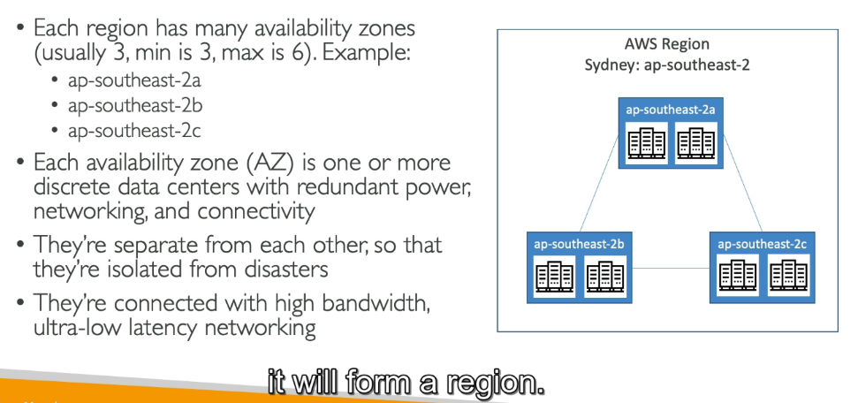It helps deliver content, such as websites, videos, or files, much faster by caching it closer to the user rather than retrieving it from the main AWS Region.

**How to choose an AWS Region**

Compliance with data governance and legal requirements : Data never leaves a region without your explicit permission.

Proximity to customers: Reduced Latency

Available services within a region: New services and new features aren’t available in every region

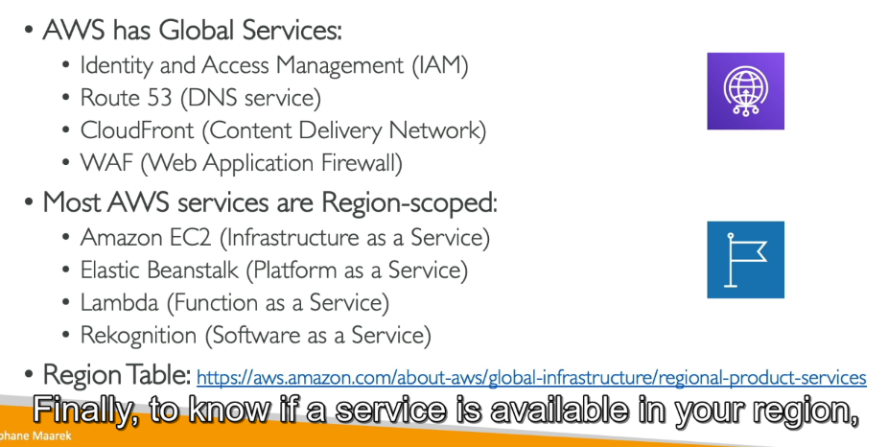Pricing: pricing varies region to region and is transparent in the service pricing range

1. **IAM: Users & Groups**

IAM= Identity and Access Management, Global Service

Here we are going to create our users and assign them to group.

Root Account is created by default while signup to aws account. The only thing you should use it for is to set up your account create IAM users.

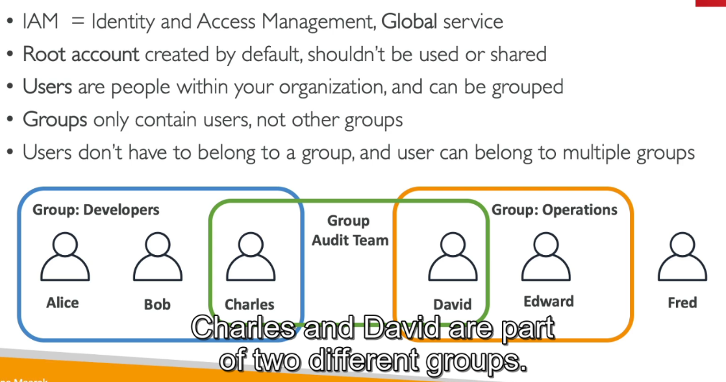

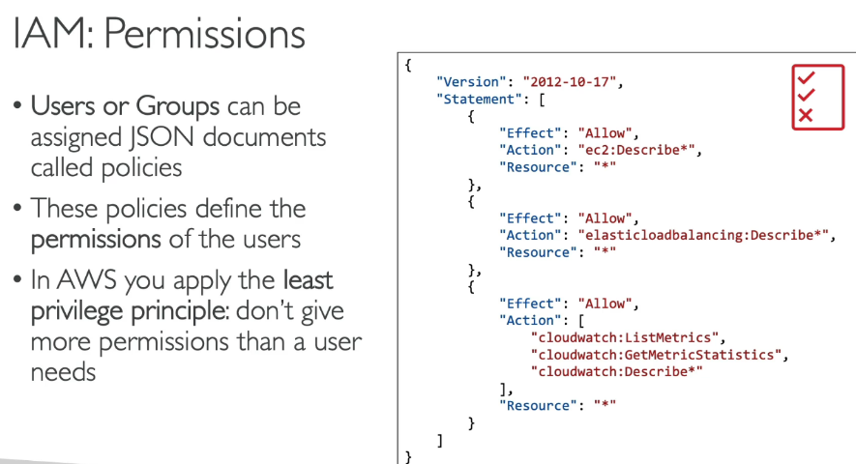**IAM: Permissions**

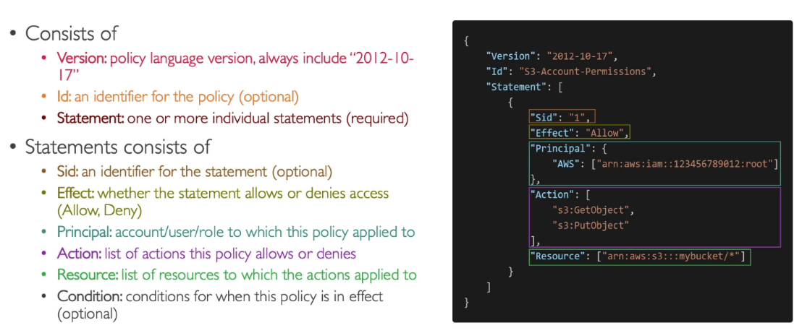**IAM Policies Structure**